* **Minify**
* Background

This function Deletes unnecessary spaces and newlines from an XML file. It accepts a string containing the XML text and returns a string containing the XML text without unnecessary spaces and newlines (i.e., the same XML as the input but written in a single line.)

* Implementation

Defining a variable to store the output XML text.

Because we are dealing with words and sentences, we don’t want to delete any space between words or sentences to keep everything as it was meant to be sent. That’s why we need to keep track of where we are now. If we are inside a sentence, we will not delete any spaces, but we will delete newlines and tabs, and if we are outside a sentence (and outside tags, obviously,) we can safely remove any spaces (i.e., to strip the sentence). This is the job of the variable *newline,* to tell us if we are inside a sentence. A value of ***true*** means that we are outside sentences.

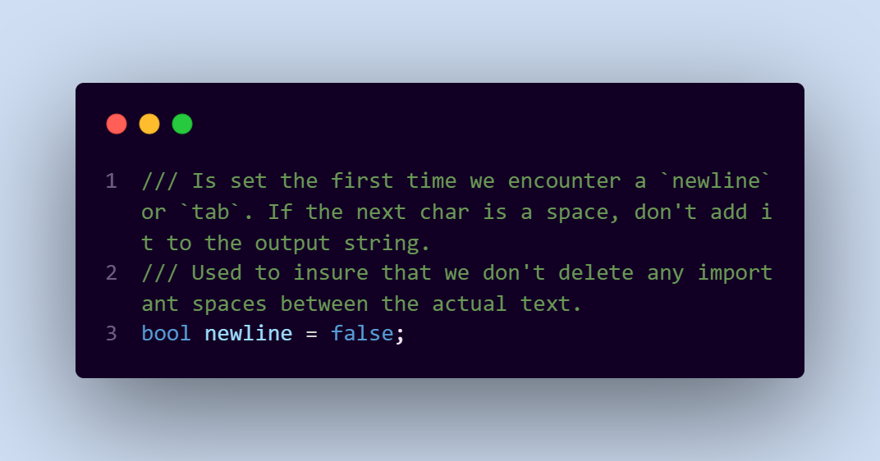

Now, we are going to loop over the XML text. All ***newlines*** and ***tabs*** will be deleted *regardless of where they are*. Only ***spaces*** will be deleted *if they are not inside a sentence*.

Finally, we conclude our work by returning the *minified* string.

* Complexity
* Time Complexity $O\left(N\right)$**,** because we need to loop over the whole string.
* Space Complexity $O\left(N\right)$**,** because we need to store the string to minify it.